**Assignment 5**

**Name: Shreyash Patil**

**PRN:** 22510039

**Batch:** T3

**Performance Testing Report for Assignment 3 & 4**

**1. Introduction** This report presents the performance testing results for the following web applications:

* **Assignment 3:** Web-enabled Student Management Information System (MIS)
* **Assignment 4:** Web-based Online MCQ Exam System

The performance testing focuses on response times, database query execution, and system load handling.

2. We can the performance in respective .csv files

Assignment 3:

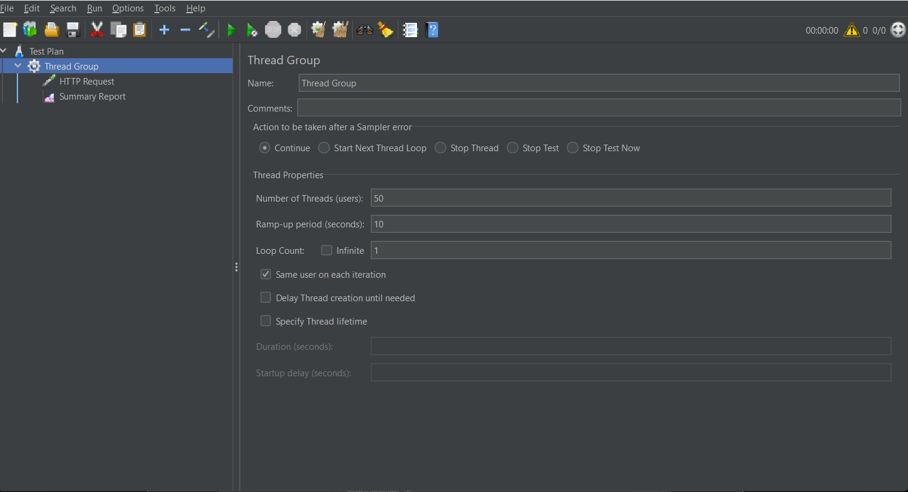

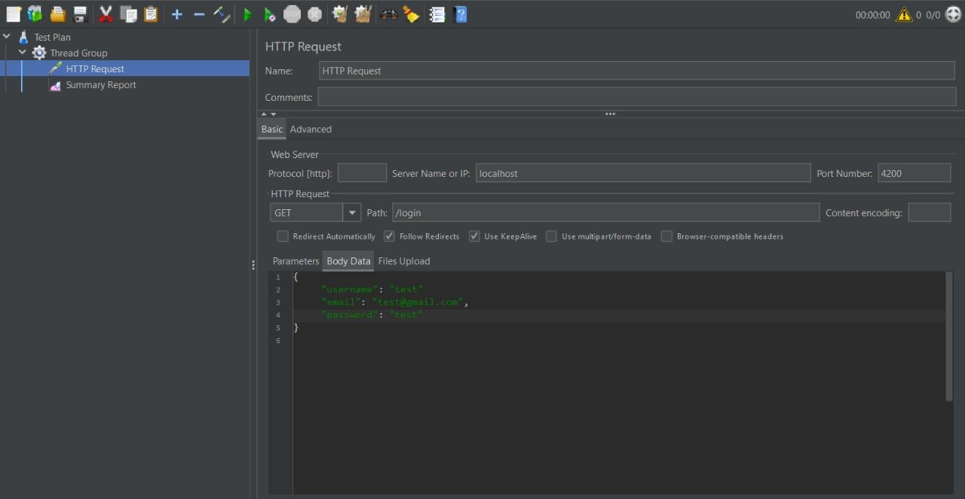

Assignment 4:

